Discussion Forums Sub-Team

What are your subteam’s research goals and outcomes that you aim to accomplish by the end of the Fall 2021 semester?
- Goal:

- Outcome:

How is your sub-team currently managing the project? (Waterfall? Agile? Hybrid?)
We are currently managing the project using the agile method. We have a Trello board and have presentations every ~4 weeks.

Name: Pratik Agarwal  Specific Role: Project Manager  Primary Responsibilities:  - Maintain the Trello board  - Lead the presentations  - Monitor progress, Support the teams when required  - Lead meetings  - Create a timeline | Name: Daniel Schall  Specific Role: Education Researcher  Primary Responsibilities:

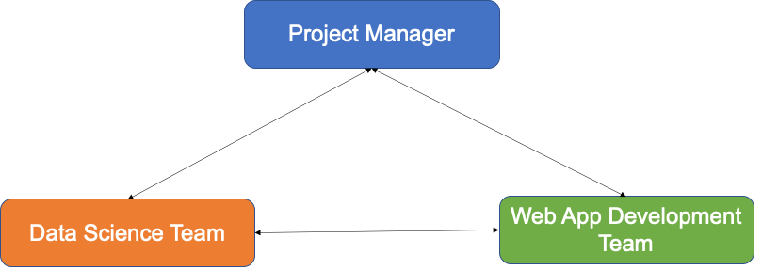

Name: Nidhi Pai  Specific Role: Data Scientist  Primary Responsibilities: |  | Name: Harriet Kim  Specific Role: Back-End Web Developer  Primary Responsibilities:
Name: Malav Patel  Specific Role: Data Scientist  Primary Responsibilities: |  | Name: Aanya Khandelwal  Specific Role: Back-End Developer  Primary Responsibilities:
Name: Jisan Park  Specific Role: Data Scientist  Primary Responsibilities: |  | Name: Gautam Sugasi  Specific Role: Back-End Developer  Primary Responsibilities:

